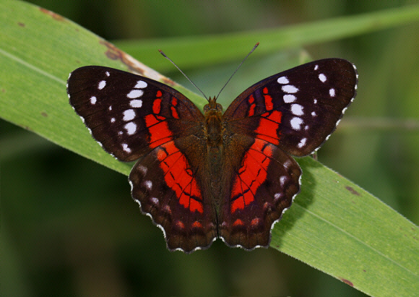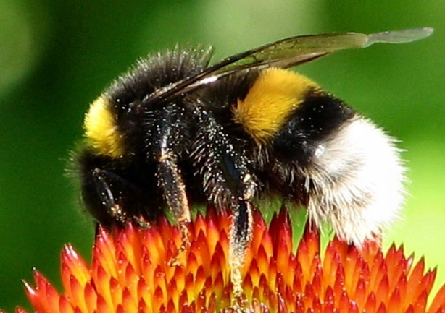

Parents,
We were due to be assessed by Eco-Schools for our second green flag in June, we will now be assessed on information we send to Eco-Schools in the first week of May.
In support of our application we hope to submit photos and pieces of work (writing, PowerPoints, videos, drawings etc.) to illustrate how our Eco-Schools ethos has been carried through to Home Learning.
This week we are asking families to undertake an environmental project together. A few ideas are listed below but if you have your own ideas or something which particularly interests you please do that. One focus of our Eco-School's work this year was healthy living so any pictures of your family being active together, doing meditation or yoga would also be a brilliant help.
- Pick a marine animal to find out about and how pollution or global warming impacts them?
- Growing, eating and cooking healthy food.
- A litter pick on the beach or around where you live. (gloves and litter pickers are essential)
- Making your garden more welcoming for nature. (There are lots of ideas on the RSPB website under make a home for nature)
- Plant flowers to encourage pollinators like butterflies and bees.
