Killer Whales

Killer whales are endangered,
One of the causes is pollution,
If we do not want them going extinct,
There is only one solution,
We can reduce using cars,
And start to cycle, walk or scoot instead,
If we do not change the way we live,
We will end up losing this species,
One of Gods creations,
So please be considerate,
And start saving our world!

…………………………………………………….

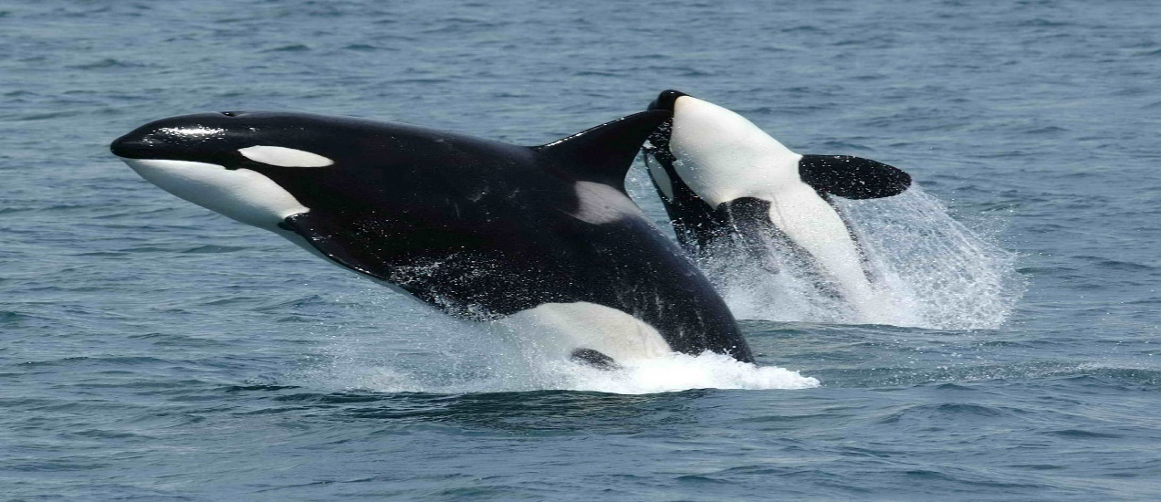
By Cara Black

